TFO1012 Modern Jewish History and Culture – Case Studies
Assessment guidelines for examinators

From course plan

Course content
The course relies on and draws from Jewish studies and the study of history, culture, art, literature and education. The students explore aspects of modern Jewish history and culture in the State of Israel and selected diaspora countries/communities. The students engage Jewish literature, Jewish art and explore Jewish influences in popular culture.

Learning outcome
After completing the course, the student has achieved the following learning outcomes defined as knowledge, skills and general competences.

Knowledge
The student has
- knowledge of modern Jewish history and culture in the State of Israel and selected diaspora countries
- knowledge of how Judaism and Jewish history are taught in public schools in Israel and the selected diaspora countries
- knowledge of aspects of Jewish literature, Jewish art and Jewish influences in popular culture

Skills
The student can
- compare and interrelate aspects of modern Jewish history and culture in different countries and communities
- interpret and discuss Jewish motifs and themes in literature, art and popular culture
- develop and conduct learning sessions about Judaism, Jewish history and antisemitism

General competence
The student has
- basic knowledge of approaches to Jewish studies and the study of history, culture, art, literature and education
- experience from collaborative and explorative learning

Mandatory assignments

Community Presentation (group assignment)
- Work together in groups of 2 or 3 (or adjust the size of the group in agreement with the teacher/instructor).
- Chose a topic pertaining to Jewish history and culture, e.g., in your home country or city or the place your ancestors lived. The case should be approved by the teacher by early December.
- Research your topic. Consult relevant course readings and/or additional adequate literature.
- Prepare a presentation based upon the model of Hiim and Hippe (1993) or a similar theoretical framework.
- Present your topic to an audience of, e.g., fellow students.
- Give an oral report to fellow Shvilim students and the teacher/instructor. Discuss what you have learned from the presentation and how it can be improved.
- If the presentation is not approved, the group makes a new presentation that draws from the evaluation and discussion.

Plan for On-site Learning Session (group assignment)
- Work together in groups of 2 or 3 (or adjust the size of the group in agreement with the teacher/instructor).
- Suggest a site and have it confirmed by teacher/instructor.
- Do research about the site: its history, its shape/architecture, its present function etc. Consult relevant course readings and/or additional (written and/or oral) sources.
- Submit a plan for the on-site learning session of 500–1000 words as part of the preparations for the Europe tour. Use the Didactic Relationship model of Hiim and Hippe (1993) or a similar theoretical framework. Include an account of your sources (course readings and additional written and/or oral sources).
- If the submitted plan is not approved, the presentation of the site and the evaluation of the learning session will count as the second submission.
During travels in USA or Europe, you will present the site and evaluate the learning session together with fellow students and teacher/instructor. As part of the evaluation, discuss what you have learned from the presentation and how it can be improved.
After the Europe trip, you may adapt and expand the teaching plan into the individual report (ca. 1500 words) that is one of two texts that are included in the portfolio exam of TFO1012.

PROPOSED STRUCTURE OF THE PLAN
- Site and sources (elaborate)
- Student’s prerequisites for learning / learning qualifications (short)
- Framework conditions/ learning situation (short)
- Learning goals (short)
- Educational content (drawn from a)
- Learning process / teaching methods (elaborate)
- If you later adapt and expand the teaching plan into the individual report (ca. 1500 words) for the portfolio exam, add:
- Evaluation (elaborate)

Examination: Portfolio exam

Portfolio instructions
The portfolio must contain two papers:
- Individual report from one of the two group assignments (Community presentation or Plan for on-site learning session), ca. 1500 words.
  - Consult and refer to relevant course readings and/or other relevant literature.
  - Include discussions about what you have learned from the assignment and how the presentation / learning session can be improved.
- Individual paper on a specific case/topic pertaining to Modern Jewish history and culture, ca. 2000 words.
  - Engage with relevant course readings and/or other adequate literature, emphasizing what you find interesting and enlightening (or wanting and problematic).
  - You may include an account of how you may present your case/topic to a particular target audience, e.g., a group of high school students.
  - You may relate to your experiences and learning outcomes during this year of study, from your work with the assignments, etc.
Make sure to cite your sources in a clear and precise manner, e.g. by using the APA7 style.
You must pass both papers to pass the whole exam.

Proposed structure of a report from the on-sight learning session
- Presentation of your site based upon adequate sources
- Description (not in full detail) of the learning session as it played out: Did it work according to your plan? Did anything go wrong? Were you forced to alter your plans and improvise? Etc.
- Evaluation of the learning session: Here you may consider the actual learning session in relation to your initial plan and refer to learning goals, educational content, learning process / teaching method, student’s prerequisites for learning / learning qualifications, and framework conditions / learning situation. You may also discuss how the learning session can be improved and/or adapted to new contexts and situations.

Proposed structure of a report from the community presentation
- Account of the topic of your community presentation based upon adequate sources
- Description (not in full detail) of the community presentation as it played out: Did it work according to your plan? Did anything go wrong? Were you forced to alter your plans and improvise? Etc.
- Evaluation of the community presentation: Here you may consider the actual learning session in relation to your initial plan and refer to learning goals, educational content, learning process / teaching method, student’s prerequisites for learning / learning qualifications, and framework conditions / learning situation. You may also discuss how the learning session can be improved and/or adapted to new contexts and situations.

Additional teaching/information given to the students

How to prepare learning sessions
The students have been taught to prepare learning sessions based on the Relationship Model of Hiim and Hippe (1993) and/or the so-called Three Questions.

The Relationship Model of Hiim and Hippe (1993)
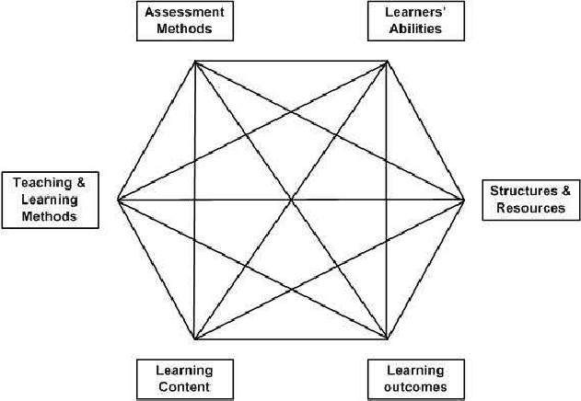

The Three Questions
- What? (contents)
- How? (methods)
- Why? (aims)

Comments and recommendations about the second paper (specific case/topic):
The students have received the following comments and recommendations:
- The course readings for this course are about USA, Israel, Norway, and popular culture. You are free to find your topic/case elsewhere, but you need to find adequate literature.
- If you write paper 1 (the report) about the Community presentation, you may choose to relate your second paper (specific care/topic) to the On-site learning session. And vice versa. You are free, however, to choose a case/topic that is not related to the earlier assignments.
- An obvious case/topic would be a specific piece/aspect of Holocaust history or of the history of Zionism and the State of Israel, but you have plenty of other opportunities: an aspect of Jewish life and culture after World War at a specific place, gender issues, a famous Jewish person, a movie, etc. But remember that you must engage with course reading or other adequate literature.
- You may even consider returning to Gordis’ book We Stand Divided and see if your trip to USA has made this book more accessible.

General criteria for assessment of the portfolio essays
- Content and presentation
- Engagement with literature
- Independence: Indications of AI tools may be considered lack of independence (and incorrect referencing).
- Correct referencing
- Correct length: +/- 15 % is ok. Larger deviations should be considered but need not automatically result in a lower grade.

Typical characteristics of essays on different levels

Report from one of the group assignments
- The report documents an excellent presentation or advanced learning outcomes of a less-than-excellent presentation, profound educational reflections, and convincing use of literature.
- The report documents a very good presentation and/or profound learning outcomes of a less-than-very good presentation, good educational reflections, and constructive use of literature.
- The report documents an ordinary presentation, constructive learning outcomes, some pedagogical reflections, and some use of literature.
- The report mostly documents the presentation, learning and reflection in an adequate manner, but there is one or more significant shortcomings, e.g. in the use of literature.
- The report partly documents the presentation in an adequate manner, but the level of learning and reflection in limited, and there are several significant shortcomings.
- The report does not document the presentation, learning, reflection and reading in an adequate manner.

Essay on individual case/topic
- The case/topic is well-chosen and presented/discussed in an excellent manner. The essay documents profound learning, advanced reflections, and convincing use of literature.
- The case/topic is well-chosen and presented/discussed in a very good manner. The essay documents profound learning, mature reflections, and constructive use of literature.
- The case/topic is adequate and presented/discussed in a good manner. The essay documents learning, reflections, and use of literature.
- The case/topic is mostly presented/discussed in an adequate manner. The essay documents learning and reflection, but there is one or more significant shortcomings, e.g. in use of literature.
- The case/topic is partly presented/discussed in an adequate manner, but the level of learning and reflection in limited, and there are several significant shortcomings.
- The essay does not document learning, reflection and reading in an adequate manner.

